Machine Description | A deliberately vulnerable lab machine for practicing web app exploits, privilege escalation, and post-exploitation to gain user and root access.
Target IP | 192.168.0.102
Vulnerability Name | 1. SQL Injection (SQLi) in OpenEMR Login Validation  2. Weak / Crackable Admin Password  3. Remote Code Execution via Config File Manipulation  4. Privilege Escalation via SUID Binary (Path Hijacking)
Port / Service | TCP / http 80
Severity | 8.1 High
Attack Vetor | CVSS:3.0/AV:L/AC:H/PR:N/UI:N/S:C/C:H/I:H/A:H
Proof of Concept (PoC) | STEP 1 – Nmap to find the IP of the target machine.  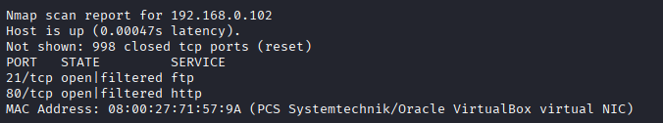  STEP 2 – Nmap Scan to discover open ports and Services  # nmap –p- -sC –sV $ip –open  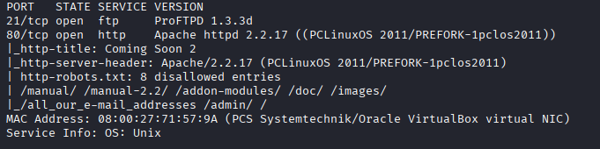  Step 3 – Found a directory using wfuzz.  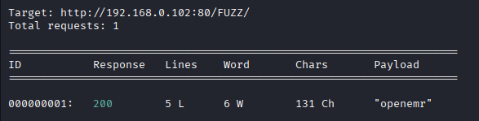  #use directory-list-2.3-big.txt for fuzzing  Step 4 – Found a login page.  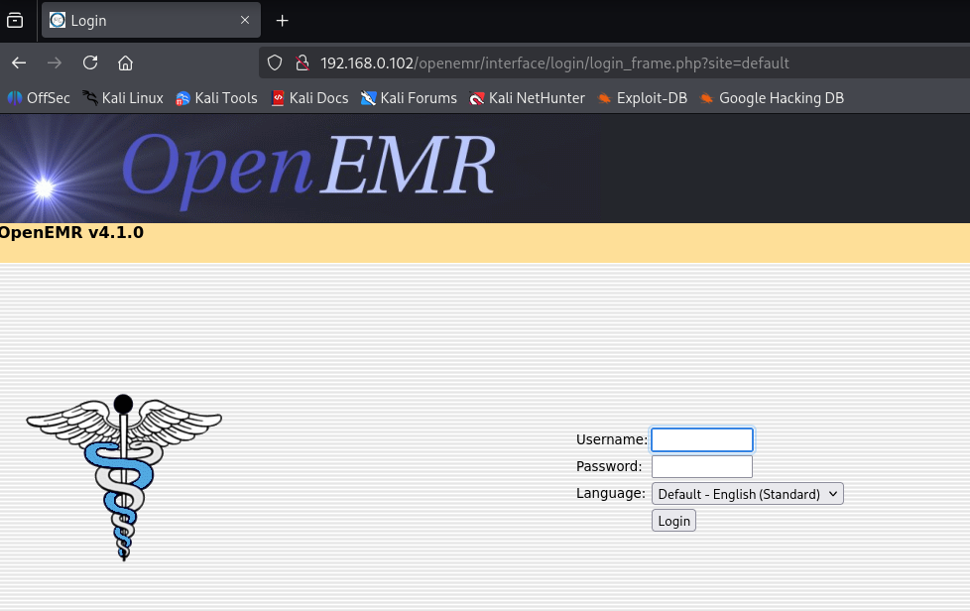  Step 5 – Found an exploit in metasploit.  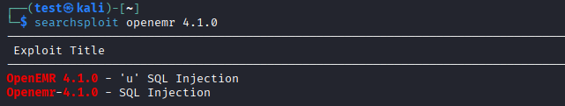  Step 6 – We used the 1st exploit and extracted the SQLi url i.e  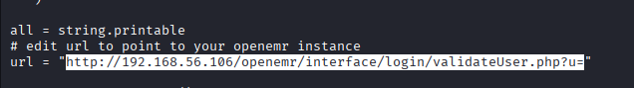  # http://192.168.0.102:80/openemr/interface/login/validateUser.php?u=  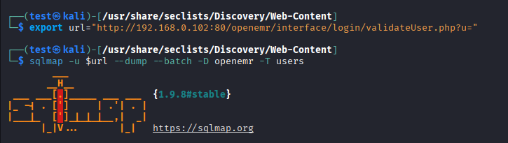  Step 7 – Loaded the url in a tool called sqlmap  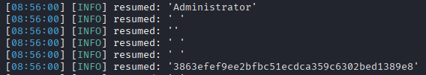  Step 8 – Found admin user’s hash  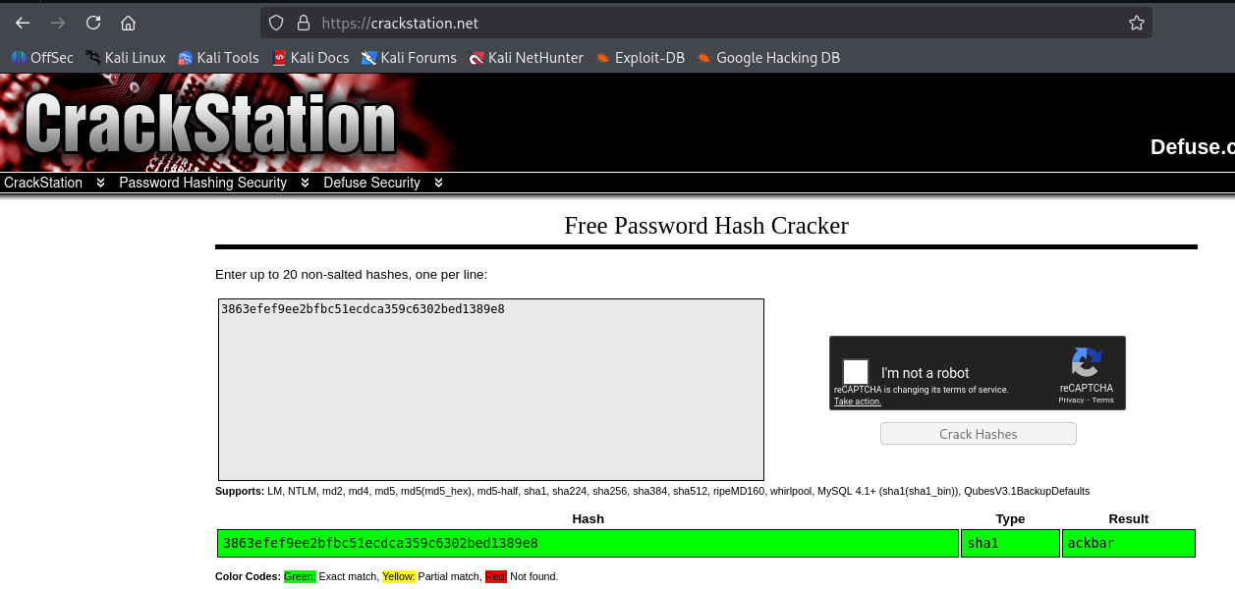  Step 9 – Used crackstation.net to crack the hash, The pswd for admin is ackbar.  Step 10 – Logged in as admin  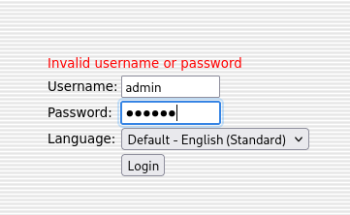  Step 11 – Found a config.php and injected code.  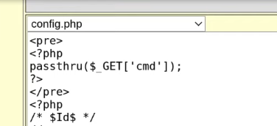  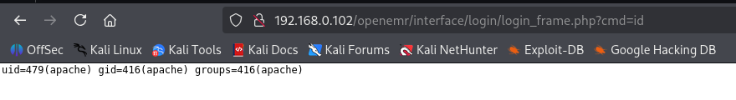  Step 12 – Now we can run scripts in the URL  Step 13 – Set the netcat listerner and encoded the script to run it in the url  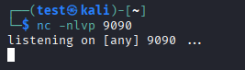  Step 14 – Got a shell  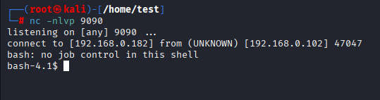  Step 15 – Found healthcheck with SUIDS, we’ll use Path highJacking.  Step 16 – Created a file with  Step 17 - Moved it to fdisk bcoz the healthcheck checks the fdisk and will execute this file.  Step 18 – We should have to append the PATH  Step 19 – Now we can run healthcheck  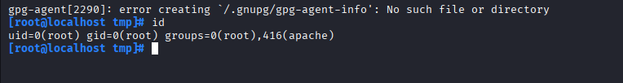  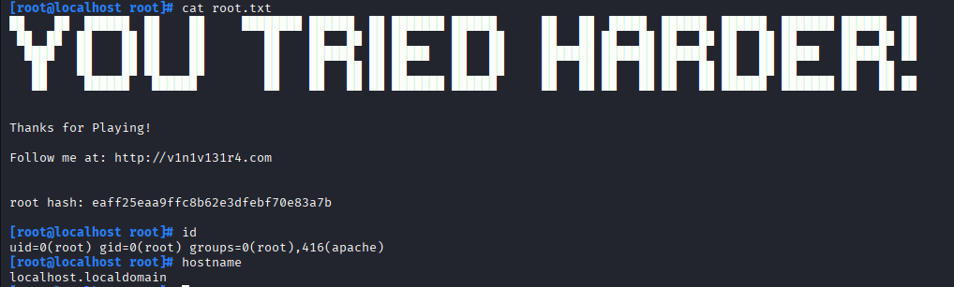  PROOF:
Remediation | • Fix SQL Injection using input validation & prepared statements  • Enforce strong passwords with policies  • Restrict permissions on sensitive files (like config.php)  • Remove or secure SUID binaries to prevent root escalation  • Update OpenEMR to latest secure version
Impact | • Attackers can steal all patient data  • Full admin and root access gained  • System can be controlled, modified, or shut down  • Complete loss of confidentiality and integrity
References | https://owasp.org/www-community/attacks/SQL_Injection  https://pages.nist.gov/800-63-3/  https://owasp.org/www-community/attacks/Code_Injection  https://gtfobins.github.io/  https://www.open-emr.org/wiki/index.php/Securing_OpenEMR

